**Version B  
Simulating a renewable powered charging station for electrical vehicles in a Goods Delivery service scenario**

**Problem Statement:**

This report describes the simulation and operations of a renewable powered charging station that serves a fleet of electric vehicles (EVs). The charging station draws energy from the power grid and is also equipped with a set of photovoltaic panels to produce renewable energy during daytime.

* The charging station, also called Battery Switching Station (BSS), caters to the fleet of EVs of a goods delivery services company and is located in the same location as a company’s warehouse.
* When the battery of an EV is low in charge, it arrives at the BSS, swaps the low-charge battery for one that has already been charged and immediately leaves.
* The low-charge battery remains at the BSS and is then recharged. Recharged batteries like these are then made available for other EVs that arrive at the BSS.
  + The low-charge batteries received from EVs can be charged until full charge or until a desired charge level is reached before being made available to another EV.
* The number of charging points or the maximum number of batteries that can be plugged in for simultaneous recharge in a BSS is denoted NBSS.
  + If all the charging points are occupied, the received batteries are added to a charging queue.
* If no battery is immediately available to an arriving EV, the EV joins a queue and waits for a maximum time of wmax before deciding to leave for another recharging station.
* The BSS is capable of providing charging power that can fully recharge an empty battery in 2-4 hours. The total capacity of the battery being 40 kWh.

**System Description:**

The key inputs needed to model the BSS system are as follows –

* Inter-arrival time of EVs
* Maximum wait time of EVs in the queue before they leave
* Number of charging units - NBSS
* Initial charge of received batteries
* Maximum Charge level of the batteries
* Charging Rate (or charging time)

The following diagram illustrates the system fully –

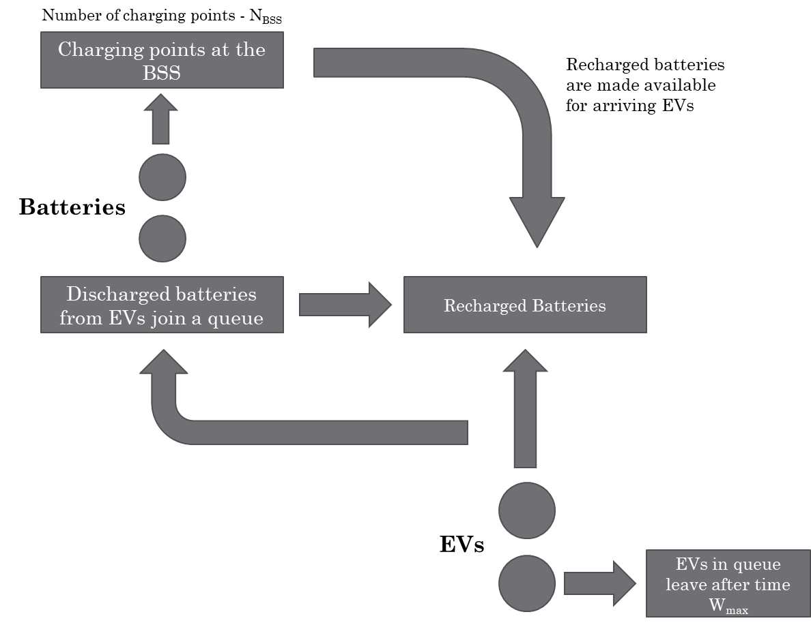

The assumptions made for the different inputs needed are as follows –

|  |  |  |
| --- | --- | --- |
| **Data** | **Definition** | **Starting Assumption** |
| N_BSS | Number of charging sockets in the station or max number of EVs that can be charged simultaneously | 2 |
| R | Charging rate at the station | 15 kW (based on 3 hour charge time) |
| MAX_iC | Maximum initial charge of the batteries | 10 kW |
| W_MAX | Maximum wait time in charging queue | 1 hour |
| IATEV | Inter arrival times of EVs | 1 hour (constant) |

Additionally, we need to define the different events that are possible in the system before proceeding with modeling it. The following events are assumed –

* EV arrival
* Discharged battery is exchanged for a recharged battery and the EV departs
* Discharged battery joins the charging queue
* Battery finishes charging and is on standby for customers
* EV misses service and departs due to long wait time

**Solutions – Investigating the System Performance:**

1. In this question, we explore the behavior of one of the performance metrics over time.   
   Typically, at the beginning of the simulations, the performance metric is in a transient state as the system moves towards equilibrium. Once equilibrium is reached, a steady state of the performance metric can be observed.

To explore this, the performance metric selected is **average waiting delay** of the EVs.

The following initial values are assumed for this question –

|  |  |
| --- | --- |
| **Input** | **Value** |
| Total capacity of each battery | 40 kWh |
| Maximum initial charge of arriving batteries | 10 kWh |
| Distribution of initial charge of arriving batteries | Uniform |
| Number of charging points at the BSS station | 2 |
| Inter-arrival rate of EVs | 1 hour |
| Distribution of inter-arrival rates | Constant |
| Maximum wait time of EVs before missed service | 1 hour |

The following graph shows the plot of average waiting delay of EVs in the queue for a single simulation run.

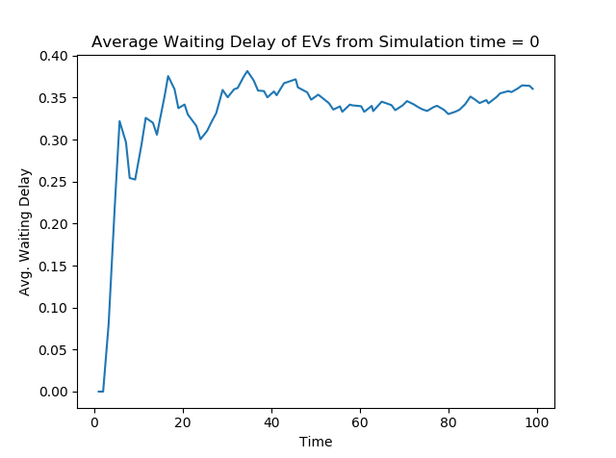

Initial Transient

Steady state

From the above graph, we can observe that there is an initial period in the simulation when the system goes through a warm up before equilibrium behavior starts to appear after a certain time instant.

Typically, in the transition from warm up to steady state, the following happens –

* The metric quickly jumps from the starting value to the steady value within the transient period.
* Once the steady state value is reached, it consolidates around that level and the variance of the metric about the steady state value decreases over time.

The warm up transient period impacts system performance metrics calculated over the period of the simulation. Since steady state results are usually desired, it is important to truncate the initial transient period before calculating the performance metrics.

We try the following methods to achieve this truncation –

* **Column Means Approach or Fishman’s approach:**  
    
  In this method, multiple simulation runs are conducted with different random seeds thus generating different data points for the performance metric at each time. Then, these points are averaged out to get a single smoothed value of the metric at each time.

By observing the smoothed trends, it becomes easier to identify the point beyond which steady state has been achieved.

This is a graphical method that suffers from subjective interpretation and thus needs to be validated using other methods.

The following graph shows the smoothing of the average waiting delay metric for 100 simulation runs –

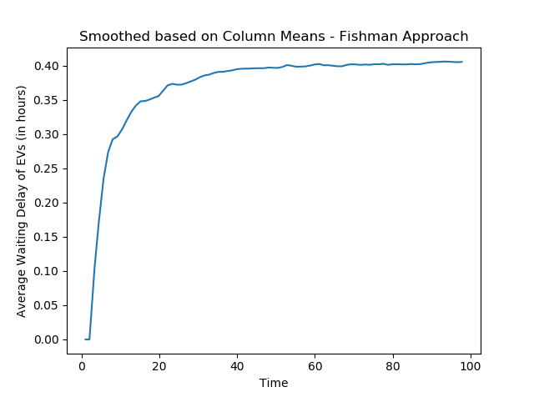

From the above graph, we notice that value of the average waiting delay metric stops changing from ~40 hours into the simulation. Therefore, this method suggests a truncation point of **time = 40**

* **Marginal Standard Error Rule (MSER) approach:**This method tries to identify the first point that is representative of the sequence following that point. It assumes that the observations in the second half of the simulation are closer in value to the true steady-state mean.

It works by calculating an objective function called the Marginal Standard Error (MSE) and identifying the local minima of this function. This local minima is the first point that is indicative of the steady state and thus is considered as the truncation point.   
The MSE objective function is shown below –

$$MSE=\frac{1}{{\left(m-d\right)}^{2}}\sum_{i=d+1}^{m}{{\left(Y_{i}- \overline{Y}\left(m, d\right)\right)}^{2}}$$

In the above equation,   
m – the total number of runs of the simulation  
d – a point in the first half of observations  
Yi – value of the metric at point i  
Y_bar – average value of the metric of all points beyond point d

Using this method and iterating over different values of d, we get the following plot of the MSE objective function.   
  
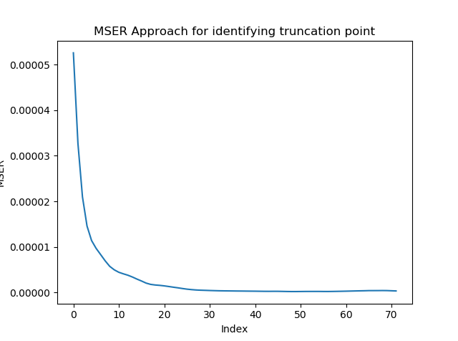

From the above graph, the MSE function has a minimum at index = 48. Therefore, this can be considered as the truncation point. This point corresponds to **time = 58**

* **Statistical Randomization Test:**This is a statistical test and thus leaves little room for subjectivity. It breaks down the length of observations from the simulation into different batches, then compares combination of first few batches with the remaining batches in the second part of the observations.   
  The null hypothesis in this test is there is no significant difference between the means of the first group (select batches from the start) and the second group (remaining batches).   
    
  From the test, if the null hypothesis is accepted, it implies that there is no significant difference between the two batches and thus indicates steady-state. The tests are conducted sequentially, starting with the first batch vs. remaining batches, then groups the first and second batch and compares them with the remaining batches and so on. The first instance when the null hypothesis is accepted gives the separation between transient state and steady state. The truncation can thus be identified this way.

$$H_{o}-There is no signficant difference between the means of the two groups$$**time = 68**

The results of the three methods used to identify the truncation point are mentioned below –

|  |  |
| --- | --- |
| **Methodology** | **Truncation Point** |
| Column Means Approach or Fishman’s approach | 40 |
| Marginal Standard Error Rule (MSER) approach | 58 |
| Statistical Randomization Test | 68 |

Based on the above results, going forward we assume a **truncation point of time = 50**.

* **Confidence levels**To determine the confidence level of the average waiting delay metric, a large number of independent runs are conducted by varying the random seed of the simulations. The resulting list of metrics then serves as the sample that can be used to estimate the confidence interval within which we would expect the actual average waiting delay.

The confidence intervals of different simulation settings are evaluated below.   
The simulation is run for different combination of simulation runs and total simulation time. The results are then compared to see how the confidence intervals vary as we increase the number of runs or increase the simulation time.   
The below table summarizes these results –   
  
**Expected Value of average waiting delay:**

|  |  |  |  |  |  |  |
| --- | --- | --- | --- | --- | --- | --- |
|  |  | **# of Runs** | | | | |
| **Total Simulation Time** |  | 100 | 200 | 500 | 750 | 1000 |
| 100 | 0.402 | 0.4019 | 0.4012 | 0.4015 | 0.4013 |
| 200 | 0.4097 | 0.4101 | 0.4096 | 0.4094 | 0.4096 |
| 500 | 0.4149 | 0.4144 | 0.4147 | 0.4146 | 0.4146 |
| 750 | 0.4184 | 0.4178 | 0.418 | 0.4179 | 0.418 |
| 1000 | 0.4181 | 0.4201 | 0.4199 | 0.4197 | 0.42 |

**Width of the Confidence Interval (95% Confidence level):**

|  |  |  |  |  |  |  |
| --- | --- | --- | --- | --- | --- | --- |
|  |  | **# of Runs** | | | | |
| **Total Simulation Time** |  | 100 | 200 | 500 | 750 | 1000 |
| 100 | 0.014 | 0.01 | 0.006 | 0.005 | 0.004 |
| 200 | 0.011 | 0.008 | 0.005 | 0.004 | 0.003 |
| 500 | 0.007 | 0.005 | 0.003 | 0.003 | 0.002 |
| 750 | 0.005 | 0.004 | 0.003 | 0.002 | 0.002 |
| 1000 | 0.006 | 0.004 | 0.003 | 0.002 | 0.002 |

It is desired that the width of the confidence interval is as narrow as possible since then we can be more confident in stating that the expected value is close to the actual value.

The following observations can be made from the above data –

* The expected value of the average waiting delay is not affected by the number of simulation runs. In all the runs, the metric consolidates at the same steady state level.
* Increasing the total simulation time affects the performance metric slightly. We can observe an increase in the steady state value from ~0.402 hours to ~0.42 hours as the number of runs increases.
* The width of the confidence interval which is a measure of the confidence level of the performance metric estimate is improved by increasing both the number of simulation runs as well as the total simulation time.
  + Higher runs and higher simulation times give a narrower CI, however it should be noted that more simulations require more computation power and more time to get the results

For the rest of the report, we fix a target confidence interval width of 0.5%, i.e. mean ± 0.25%.

This target level can be achieved using total simulation time = 500 and # of runs = 200. Going with a higher simulation time also helps improve the estimated value of the performance metric, thus this seems to be a good choice.

1. In this question, the following updates are made to the system –
   1. The inter arrival times of EVs is modified to vary based on the hour of the day. The inter arrival times also follow an exponential distribution now.
   2. During certain times of the day, a partially recharged battery can be picked by an arriving EV if no fully charged battery is available. A minimum charge threshold, Bth, needs to be attained for this.

The assumptions made are as follows –

**Inter arrival times:**

* Hours 0 to 7
  + During night time only a small number of EVs circulate and thus arrivals are very few
  + Very low frequency of arrivals assumed
* Hours 7 to 13
  + In the morning, many EVs that were waiting overnight for long distance deliveries depart for their destinations. There are only a few arrivals.
  + Low frequency of arrivals assumed
* Hours 13 to 20
  + Increased EV circulation during this period as many EVs that started in the morning return and there will be many short distance deliveries. Also, additional EVs would require charging in the middle of the day.
  + High frequency of arrivals assumed
* Hours 20 to 23
  + Arrivals mostly include those EVs that are left overnight for next day deliveries
  + Medium frequency of arrivals assumed

The λ rates for the exponential distribution are as follows –

|  |  |  |  |  |
| --- | --- | --- | --- | --- |
| Hour of day | 0 – 7 | 7 – 13 | 13 – 20 | 20 – 23 |
| λ | 0.25 | 0.75 | 1 | 2 |

**Partially Charged Battery Pickup:**

The minimum charge required for a battery to be picked up and the hours of day during which this is allowed are as follows –

|  |  |
| --- | --- |
| Peak hours of day during which EVs can pick-up partially charged batteries | 13 - 20 |
| Minimum charge to be eligible | 30 kWh |

The results of this scenario is compared with that of the previous scenario as follows –

**Updated Scenario – Q2** **Previous Base Scenario – Q1**

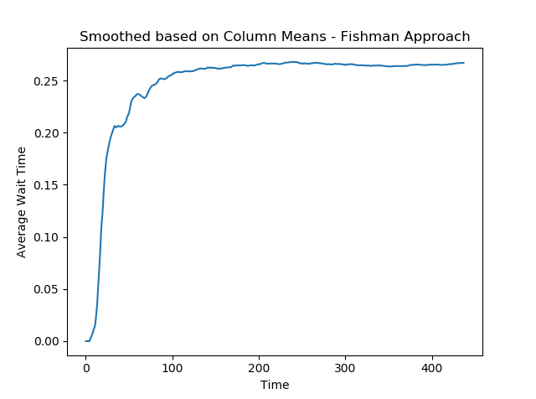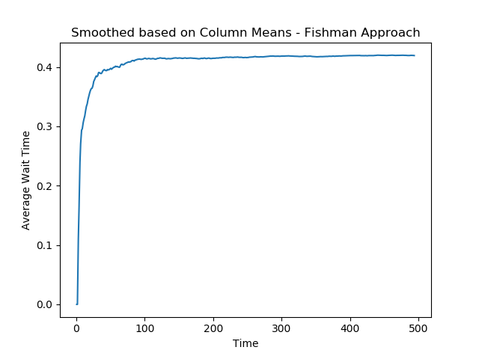

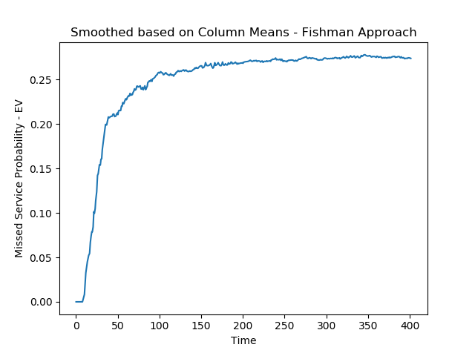 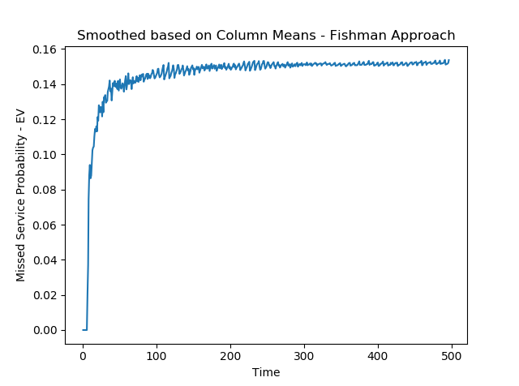

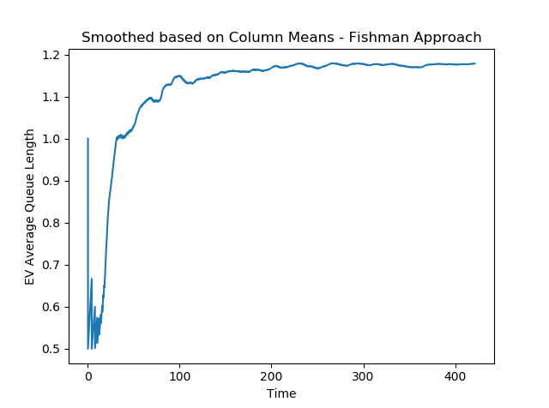 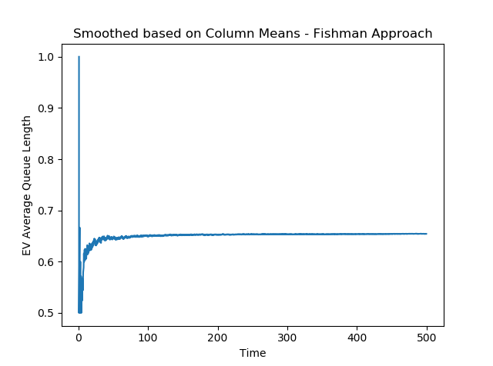

**Updated Scenario – Q2** **Previous Base Scenario – Q1**

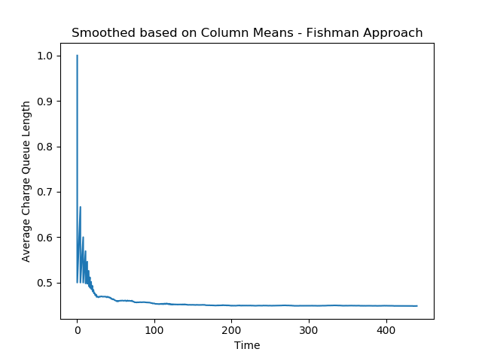 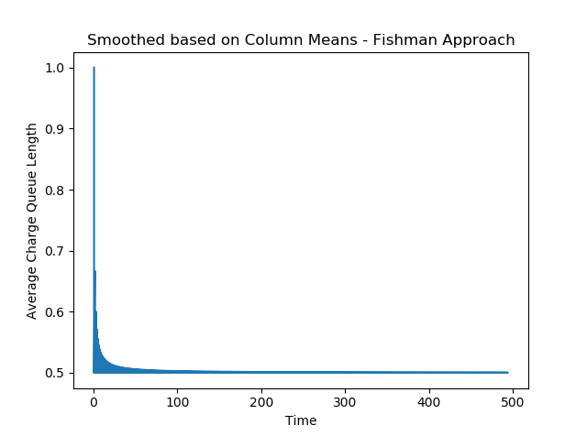

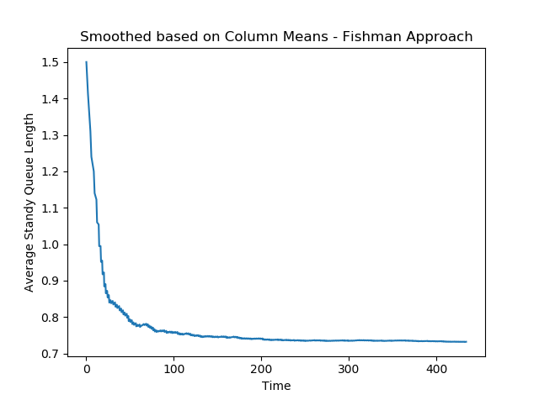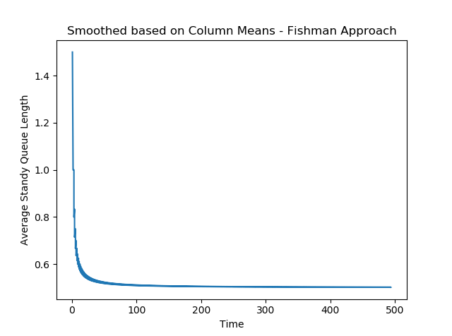

From the comparisons above, there are a couple of evident observations –

* In the new scenario, the system takes longer to reach equilibrium than in the previous scenario. This can be attributed to the higher degree of randomness in the system from the assumption around exponential arrival rates and higher periodicity in the arrival rates of EVs since adjacent timeframes have different patterns.
  + This implies the new scenario requires a higher transient truncation cut-off.
* On average, the number of EVs arriving and their missed service probability has increased. This is probably due to the higher frequency of EV arrival during peak hours.

1. In this question, it is assumed that the charging station is equipped with a set of PV panels that produce solar power. The station draws power from the grid when solar power is insufficient or not generated.

A cost analysis is conducted to assess the impact of the number of PV panels and the number of charging points on the overall cost. This is done as follows –

* Through simulation, calculate the average station utilization by hour on any given day
  + Utilization is defined as the % of time during the hour in which the charging capacity of the station is utilized by discharged batteries
* Using electricity cost and PV panel production inputs provided along with the average utilization by hour, calculate the total cost of electricity during the day
  + Power generated through PV panel is assumed to have no cost and is used to figure out the power needed from the grid
  + The electricity costs and PV panel production is split by season and hour of day. This way the differential cost between summer and winter is calculated.

For this analysis, the same base assumptions used for question 2 is applied. The arrival times are exponential random and vary by time of day. Therefore, we expect the utilization of the station to be differ based on hour of the day.

The average utilization by hour from the simulation is shown below –

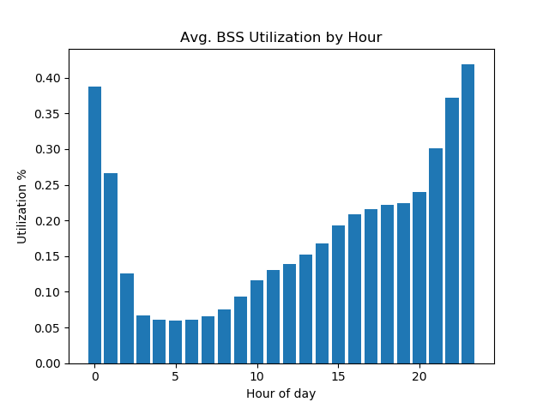

Late in the night, there is very little EV traffic and most of the batteries received earlier in the night have already been charged. Thus, the station utilization is low.   
Utilization starts to increase in the morning as EVs start arriving and it peaks at the end of the day when most of the EVs return and batteries are charged overnight for deliveries the following day.

Using this utilization trend, we now assess how the total power cost incurred by the station differs by season and how much of an impact the number of PV panels deployed and the number of charging points available have on the cost.

The below tables shows the costs broken down by these three cuts.

**Summer Day:** Values shown are average daily costs in € / day

|  |  |  |  |  |  |  |
| --- | --- | --- | --- | --- | --- | --- |
|  |  | **Number of Charging Points, NBSS** | | | | |
|  |  | **2** | **3** | **5** | **7** | **10** |
| **Number of 1kW PV Panels,  SPV** | **100** | 15.0 | 19.7 | 24.7 | 26.4 | 26.5 |
| **200** | 13.6 | 18.1 | 22.8 | 23.9 | 24.3 |
| **500** | 12.4 | 16.5 | 20.8 | 21.9 | 22.1 |
| **700** | 12.1 | 16.0 | 20.3 | 21.5 | 21.7 |
| **1000** | 11.8 | 15.7 | 20.0 | 21.1 | 21.4 |

**Winter Day:** Values shown are average daily costs in € / day

|  |  |  |  |  |  |  |
| --- | --- | --- | --- | --- | --- | --- |
|  |  | **Number of Charging Points, NBSS** | | | | |
|  |  | **2** | **3** | **5** | **7** | **10** |
| **Number of 1kW PV Panels,  SPV** | **100** | 18.3 | 23.5 | 28.3 | 30.0 | 30.5 |
| **200** | 17.0 | 22.1 | 26.7 | 27.8 | 28.4 |
| **500** | 16.0 | 20.6 | 25.1 | 26.2 | 26.5 |
| **700** | 15.6 | 20.1 | 24.5 | 25.7 | 26.2 |
| **1000** | 15.5 | 19.8 | 24.1 | 25.1 | 25.6 |

Cost per day during winter is higher than in summer due to lesser power generated by the PV panels. Increasing the number of panels leads to more power generation especially during summer and thus lower costs.   
Options like increasing both the number of panels and the number of charging points is worth considering as the effective cost doesn’t change much from lower number of both.

As observed above, there is a big difference between the utilization at different points in the day. Now, we evaluate the strategy of postponing the charging of a % of batteries when the electricity prices are high and solar energy is not generated to a time when prices are low. This way by restructuring the charging schedule, it is possible to reduce cost.

Three parameters are assumed –

* f - % of batteries in charge queue that are postponed
* Tmax – the maximum time that can be postponed – uniform distribution is assumed
* Hours of the day when the postponement is applicable

By looking at the hourly prices and hourly PV production, it is possible to figure out a window for the postponement strategy. Electricity prices are relatively higher in the morning and in the evenings. However, in the morning, there is some solar power generation. Thus, we fix this window to the post sunset period when the station utilization is also quite high.

Assumed window for postponement (hours of the day) – 19, 20, 21, 22, 23

The below tables summarize the costs after implementing this strategy.   
Note that the initial cost for this scenario (SPV = 100, NBSS = 2) was 15.0 during summer and 18.3 during winter.

**Summer Day:** Values shown are average daily costs in € / day

|  |  |  |  |  |  |  |
| --- | --- | --- | --- | --- | --- | --- |
|  |  | **Maximum postponement hours, Tmax** | | | | |
|  |  | **4** | **5** | **6** | **7** | **8** |
| **% of Batteries postponed,  f** | **25%** | 13.5 | 13.4 | 13.3 | 13.1 | 12.9 |
| **50%** | 12.4 | 12.2 | 11.9 | 11.7 | 11.5 |
| **75%** | 12.1 | 11.2 | 10.7 | 10.4 | 10.1 |

**Winter Day:** Values shown are average daily costs in € / day

|  |  |  |  |  |  |  |
| --- | --- | --- | --- | --- | --- | --- |
|  |  | **Maximum postponement hours, Tmax** | | | | |
|  |  | **4** | **5** | **6** | **7** | **8** |
| **% of Batteries postponed,  f** | **25%** | 16.7 | 16.8 | 16.8 | 16.6 | 16.3 |
| **50%** | 15.9 | 15.7 | 15.3 | 15.3 | 15.2 |
| **75%** | 15.6 | 14.9 | 14.5 | 14.2 | 13.9 |

Therefore, for example, by postponing the charging of 75% of batteries during the evenings hours from 16:00 to 00:00 by up to 8 hours decreases the cost per day to ~€10 from ~€15 during summer days.   
Similarly, there is a benefit from ~€18 to ~€€13 during winter days.

We should check if this benefit is because of just the cost savings or also because the number of EVs serviced has decreased. Below are the corresponding missed service probabilities for this scenario. For reference, missed service probability in the base scenario without postponement is 0.29

|  |  |  |  |  |  |  |
| --- | --- | --- | --- | --- | --- | --- |
|  |  | **Maximum postponement hours, Tmax** | | | | |
|  |  | **4** | **5** | **6** | **7** | **8** |
| **% of Batteries postponed,  f** | **25%** | 0.33 | 0.28 | 0.32 | 0.34 | 0.31 |
| **50%** | 0.32 | 0.35 | 0.33 | 0.38 | 0.38 |
| **75%** | 0.36 | 0.37 | 0.41 | 0.39 | 0.41 |

Therefore, in general, more EVs will miss service with this strategy. It is important to assess the trade off between cost benefit and lost business to make the best strategy choice.

However, it appears that postponement of 50% of batteries by 4 hours seems like a good option as that reduces the cost substantially while resulting in a 3% higher missed service probability.

Below will be the new utilization with this strategy. Most charging that was concentrated at the end of the day have shifted to post mid night when arrivals are few and utilization is low.

